

A
REPORT
ON
ELECTRONIC SKILL DEVELOPMENT PROJECT

SUBMITTED TO UNIVERSITY OF PUNE FOR PARTIAL FULFILLMENT OF THE REQUIREMENTS FOR THE DEGREE OF
BACHELOR OF ENGINEERING
In
Electronics and Telecommunication

PROJECT TITLE:
Smart Parking gate System

By

Name of Candidates
- Sagar Parve (24112005)
- Udaysinh Patil (24112044)
- Dnyaneshwar Pawar(24112066)

DEPT. OF ELECTRONICS AND TELECOMMUNICATION
PUNE VIDYARTHI GRIHA’S COLLEGE OF ENGINEERING, TECHNOLOGY
AND MANAGEMENT,
PUNE-9

2025-26

CERTIFICATE

This is to certify that the Electronic Skill Development Project Report entitled “SMART PARKING GATE SYSTEM”
Under Electronics skill development lab
has been successfully completed by

Name of Candidate
- Sagar Rambhau Parve
- Udaysinh Shahaji Patil
- Dnyaneshwar Pawar

towards the partial fulfillment of the degree of Bachelor of Engineering in Electronics and Telecommunication as awarded by the Savitribai Phule Pune University, at Pune Vidyarthi Griha’s College of Engineering, Technology & Management during the academic year 2025-26.

Prof. U. A. Walke Dr. P. G. Shete Sir
Subject Teacher Head, Department Of E&TC

Place: Pune

Date:

ACKNOWLEDGEMENTS

We express our sincere gratitude to our project guide Prof. . U. A. Walke for their constant guidance, encouragement, and valuable suggestions throughout this project.

We are thankful to Prof. Dr.P.G.Shete Sir Head of Department of Electronics and Telecommunication Engineering, for providing necessary facilities and support.

We also thank all the faculty members of the E&TC department for their cooperation and motivation during this work. We extend our thanks to our family and friends for their continuous moral support.

Please acknowledge everybody who were involved and helped you in completing this report/thesis/project work. But keep this brief and resist the temptation of writing flowery prose. Do include all those who helped you, e.g. other faculty / staff you consulted, colleagues who assisted etc. Acknowledge the source of any work that is not your own.

Name of Candidates
- Sagar Rambhau Parve
- Udaysinh Shahaji Patil
- Dnyaneshwar Pawar

 | Abstract |  | i
 | List of Acronyms |  | ii
 | List of Symbols |  | iv
 | List of Figures |  | vi
 | List of Tables |  | vii
1 | Introduction
 | 1.1 | Background and Context
 | 1.2 | Relevance
 | 1.3 | Literature Survey
 | 1.4 | Motivation
 | 1.5 | Problem Definition
 | 1.6 | Scope and Objectives
 | 1.7 | Organization of the Report
2 | Project System Design Methodology
 | 2.1 | Introduction
 | 2.2 | Block diagram of system and working of the system
 | 2.3 | Selection of components
 | 2.4 | Specifications
3 | Development and Testing
 | 3.1 | Introduction
 | 3.2 | Simulation
 | 3.3 | PCB Artwork
 | 3.4 | Layout Versus Schematic verification report
4 | EMI & EMC standards implemented in the project
5 | Results
6 | Conclusions and Future Scope
7 | Bill of Material
 | References
 | Appendix
 | Datasheets

CONTENTS

ABSTRACT

The rapid increase in urbanization and the growing number of vehicles have created major challenges in parking management systems, especially in residential societies, commercial complexes, and educational institutions. Conventional parking systems mainly depend on manual operation, which often results in traffic congestion, increased waiting time, and inefficient vehicle management. To overcome these problems, this project presents the design and implementation of a Smart Parking Gate System using the ATmega16A microcontroller. The system is designed to automate vehicle entry and exit operations, thereby improving efficiency, reducing human effort, and ensuring smooth traffic flow.

The proposed system uses IR sensors to detect the presence of vehicles at the parking gate. Whenever a vehicle interrupts the IR sensor beam, the sensor sends a signal to the microcontroller, which processes the input and controls a servo motor using PWM signals. The servo motor automatically opens the gate by rotating to a specific angle and closes it after the vehicle passes through the gate. The entire operation is performed automatically without human intervention, making the system reliable and efficient. The system operates on a regulated 5V power supply and is programmed using Embedded C language for real-time control and fast response.
The circuit design and functionality were first tested in Proteus simulation software before hardware implementation to ensure proper operation and stability. The practical implementation confirmed that the system works accurately with quick sensor response and smooth gate movement. The proposed Smart Parking Gate System is low-cost, easy to implement, and suitable for small to medium-scale parking applications. In future, the system can be enhanced by integrating technologies such as RFID-based vehicle authentication, IoT monitoring, and LCD displays for parking information, transforming it into a more advanced intelligent parking management system.

LIST OF ACRONYMS

Acronym | Full Form
MCU | Microcontroller Unit
IR | Infrared
AVR | Alf and Vegard's RISC
RISC | Reduced Instruction Set Computer
GPIO | General Purpose Input/Output
PWM | Pulse Width Modulation
ADC | Analog-to-Digital Converter
VCC | Supply Voltage
GND | Ground
LCD | Liquid Crystal Display
LED | Light Emitting Diode
IDE | Integrated Development Environment
ISP | In-System Programming
UART | Universal Asynchronous Receiver Transmitter
SPI | Serial Peripheral Interface
I2C | Inter-Integrated Circuit
IC | Integrated Circuit
PCB | Printed Circuit Board
EMI | Electromagnetic Interference
EMC | Electromagnetic Compatibility
DRC | Design Rule Check
ERC | Electrical Rule Check
EEPROM | Electrically Erasable Programmable Read-Only Memory
SRAM | Static Random-Access Memory
CPU | Central Processing Unit
F_CPU | CPU Clock Frequency
HEX | Hexadecimal File
THT | Through-Hole Technology
SMD | Surface Mount Device
Vout | Output Voltage
Vin | Input Voltage

LIST OF SYMBOLS

Symbol | Description | Unit
V | Voltage | Volts (V)
I | Current | Amperes (A)
R | Resistance | Ohms (Ω)
P | Power | Watts (W)
t | Time | Seconds (s)
f | Frequency | Hertz (Hz)
θ | Servo Motor Angle | Degrees (°)
Vcc | Supply Voltage | Volts (V)
Vin | Input Voltage | Volts (V)
Vout | Output Voltage | Volts (V)
I_load | Load Current | Amperes (A)
f_clk | Clock Frequency of MCU | Hertz (Hz)
T_pwm | PWM Time Period | Seconds (s)
D | Duty Cycle | Percentage (%)
τ | Time Constant | Seconds (s)
V_IR | IR Sensor Output Voltage | Volts (V)
N | Prescaler Value | —
TOP | Timer Maximum Count Value | —
T_delay | Delay Time for Gate Operation | Seconds (s)

LIST OF FIGURES

Figure No. | Caption | Page No.
Fig. 2.1 | Block Diagram of Smart Parking Gate System | 13
Fig. 2.2 | IR Sensor Module | 15
Fig. 2.3 | Servo Motor (SG90) | 16
Fig. 2.4 | 7805 Voltage Regulator | 17
Fig.2.5 | Crystal Oscillator ( 8 MHz) | 18
Fig. 3.1 | Simulation Using Proteus | 23
Fig. 3.2 | Schematic Design of PCB | 25
Fig. 3.3 | PCB Layout (Top View) | 26
Fig. 3.4 | 3D PCB View | 27

CHAPTER 1
INTRODUCTION
1.1 Background and Context
With the rapid growth of urbanization and the increasing number of vehicles, parking management has become a major challenge in cities and semi-urban areas. Traditional parking systems rely on manual gate operation and human supervision, which often leads to inefficiencies such as increased waiting time, traffic congestion, and mismanagement of parking spaces. These systems are not only time-consuming but also prone to human errors.
In recent years, automation and embedded systems have played a significant role in improving infrastructure and daily operations. Smart systems are being widely adopted in various domains such as transportation, security, and energy management. A Smart Parking Gate System is one such application that uses embedded technology to automate vehicle entry and exit processes. By integrating sensors and microcontrollers, the system can detect vehicles and control gate movement automatically.
The ATmega16A microcontroller, based on AVR architecture, provides an efficient and cost-effective platform for implementing such automation systems. With features such as multiple GPIO pins, timers, and PWM capability, it is well-suited for real-time control applications like parking gate automation.

1.2 Relevance
The Smart Parking Gate System is highly relevant in today’s context of smart cities and automation. Efficient parking management is essential for reducing traffic congestion and improving the overall transportation system. Automated gate systems reduce the dependency on manual labour and ensure faster operation.
This project is particularly useful for small to medium-scale parking areas such as colleges, residential complexes, office buildings, and shopping centres. It provides a low-cost solution compared to advanced systems like RFID-based or camera-based parking systems. Moreover, it aligns with the academic curriculum of Electronics and Telecommunication Engineering by providing practical exposure to embedded systems, sensor interfacing, and real-time control.

1.3 Literature Survey
Several studies and existing systems have explored different techniques for parking automation. Some systems use RFID technology for vehicle identification and access control, while others use ultrasonic sensors or camera-based image processing for vehicle detection and slot management.
RFID-based systems provide secure access control but increase the overall cost and complexity of the system. Ultrasonic sensor-based systems are commonly used for parking slot detection but may face accuracy issues due to environmental conditions. Camera-based systems offer advanced features but require high computational power and are expensive.
In comparison, IR sensor-based systems provide a simple, cost-effective, and reliable solution for basic vehicle detection. When combined with a microcontroller like ATmega16A, these systems can efficiently automate gate control without requiring complex hardware or software. Therefore, this project focuses on implementing a simple yet effective parking gate automation system using IR sensors.

1.4 Motivation
The primary motivation behind this project is to develop an efficient and low-cost automated parking gate system that reduces human effort and improves operational efficiency. Manual gate systems are slow and require constant supervision, which is not practical in many scenarios.
Additionally, this project provides an opportunity to apply theoretical knowledge of microcontrollers, sensors, and embedded systems to a real-world application. It helps in understanding how hardware and software interact to create automated solutions. The use of ATmega16A allows students to gain hands-on experience with AVR microcontrollers, which are widely used in embedded system design.

1.5 Problem Definition
A conventional parking gate system suffers from several drawbacks, including:
- Dependence on manual operation
- Increased waiting time for vehicles
- Inefficient traffic flow
- Possibility of human error
- Lack of automation and intelligence
The problem addressed in this project is the design and implementation of an automated parking gate system that can detect vehicles and control gate operation without human intervention. The system must be reliable, cost-effective, and easy to implement using embedded system technology.

1.6 Scope and Objectives
Scope:
The project focuses on designing a microcontroller-based parking gate system using ATmega16A, IR sensors, and a servo motor. The system is intended for small-scale applications and does not include advanced features such as vehicle identification or remote monitoring.
Objectives:
- To design a Smart Parking Gate System using ATmega16A
- To detect vehicle presence using IR sensors
- To control gate movement using a servo motor
- To implement PWM-based control for accurate servo operation
- To reduce manual effort and improve efficiency
- To develop a cost-effective and reliable solution

1.7 Organization of the Report
This report is structured as follows:
- Chapter 1: Introduction – Provides background, relevance, motivation, and objectives of the project
- Chapter 2: Project System Design Methodology – Describes system design, block diagram, and component selection
- Chapter 3: Development and Testing – Covers simulation, hardware implementation, and testing
- Chapter 4: EMI & EMC Considerations – Discusses noise reduction and design standards
- Chapter 5: Results – Presents system performance and observations
- Chapter 6: Conclusion and Future Scope – Summarizes the project and suggests improvements
- Chapter 7: Bill of Materials – Lists components and cost details

CHAPTER 2
PROJECT SYSTEM DESIGN METHODOLOGY

2.1 Introduction
This chapter describes the complete system design methodology of the Smart Parking Gate System using the ATmega16A microcontroller. It includes the overall system architecture, block diagram, working principle, component selection, and system specifications. The design focuses on creating a simple, efficient, and cost-effective automated parking gate system.

2.2 Block Diagram of System and Working of the System
Objective of the Project:
To design and implement an automated parking gate system that detects vehicle presence using IR sensors and controls gate operation using a servo motor, all managed by the ATmega16A microcontroller.

Block Diagram:
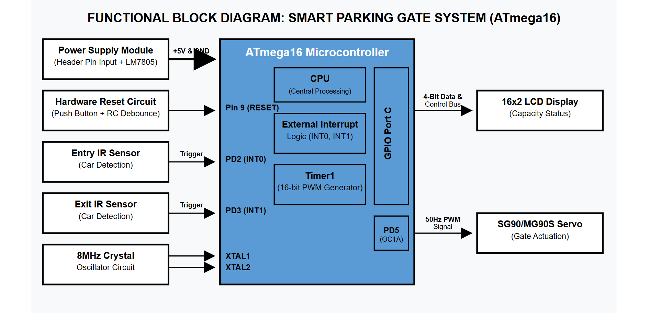
Fig. 2.1

Description of Blocks:
- IR Sensor: Detects the presence of a vehicle by sensing interruption in infrared rays.
- ATmega16A Microcontroller: Processes sensor input and generates control signals.
- Servo Motor: Acts as the gate mechanism, opening and closing based on control signals.
- Power Supply Unit: Provides regulated 5V to all components.
- Crystal Oscillator: Generates clock signal (16 MHz) for microcontroller operation.

Working of the System:
The system operates in a continuous loop where the IR sensor monitors vehicle presence. When a vehicle is detected, the sensor sends a digital signal to the ATmega16A microcontroller. The microcontroller processes this signal and activates the servo motor using PWM generated by Timer1.
The servo motor rotates to approximately 90 degrees to open the gate. After a predefined delay of 5 seconds or once the vehicle passes, the microcontroller sends another PWM signal to return the servo motor to its original position (0 degrees), thereby closing the gate.
This automated operation eliminates manual intervention and ensures smooth traffic flow at the parking entrance.

2.3 Selection of Components
Table 2.1: Microcontroller Comparison
Parameter | ATmega16A | ATmega328P | PIC16F877A
Architecture | 8-bit AVR | 8-bit AVR | 8-bit PIC
Flash Memory | 16KB | 32KB | 14KB
GPIO Pins | 32 | 23 | 33
ADC Channels | 8 | 6 | 8
PWM Channels | Yes | Yes | Yes
Operating Voltage | 2.7–5.5V | 1.8–5.5V | 2.0–5.5V
Package | DIP-40 | DIP-28 | DIP-40

Justification for Selecting ATmega16A:
- Provides sufficient GPIO pins for sensor and actuator interfacing
- Supports PWM generation using internal timers
- Compatible with 5V logic circuits
- Easy to program using Embedded C
- Cost-effective and suitable for academic projects

Other Components Selection:
- IR Sensor Module
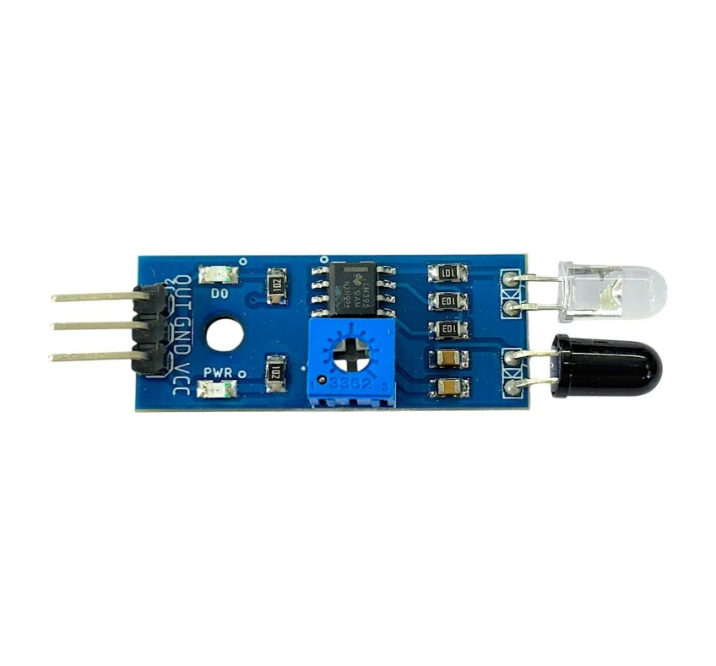
Fig. 2.2

Description:
The IR (Infrared) sensor module is used for detecting the presence of a vehicle. It consists of an IR transmitter (LED) and an IR receiver (photodiode). When an object (vehicle) comes in front of the sensor, the IR rays are reflected back and detected by the receiver.
Reason for Selection:
- Low cost and easily available
- Simple interfacing with microcontroller (digital output)
- Fast response time (<10 ms)
- Suitable for short-range detection (2–10 cm)
Working Principle:
When no object is present, IR rays are not reflected → output = LOW
When object detected → IR rays reflected → output = HIGH

- Servo Motor (SG90)
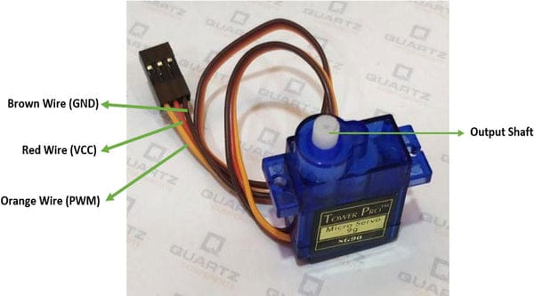
Fig. 2.3

Description:
The servo motor is used as the gate actuator. It rotates to a specific angle based on PWM signals from the ATmega16A.
Reason for Selection:
- Precise angular control (0°–180°)
- Easy PWM control using Timer1
- Low power consumption
- Compact size suitable for small models
Working Principle:
The servo rotates based on pulse width:
- 1 ms → 0° (Gate Closed)
- 1.5 ms → 90° (Gate Open)
- 2 ms → 180°

- 7805 Voltage Regulator
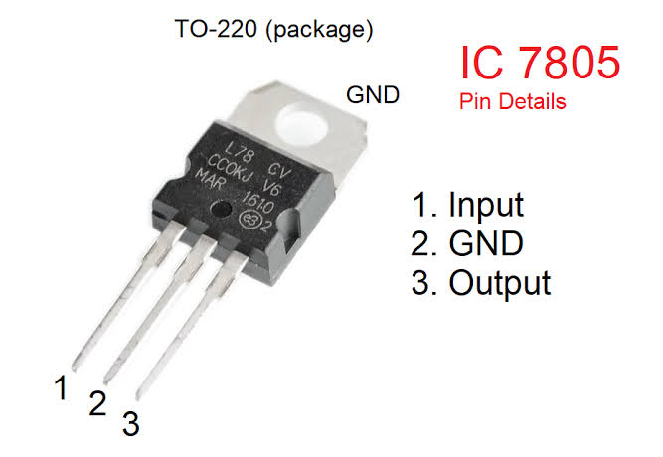
Fig. 2.4

Description:
The 7805 is a linear voltage regulator used to convert input voltage (9–12V) into a stable 5V output required for the ATmega16A and other components.
Reason for Selection:
- Provides constant 5V output
- Protects circuit from voltage fluctuations
- Simple and reliable design
- Widely used in embedded systems
Working Principle:
Input voltage → regulated internally → fixed 5V output

- Crystal Oscillator ( 8 MHz)
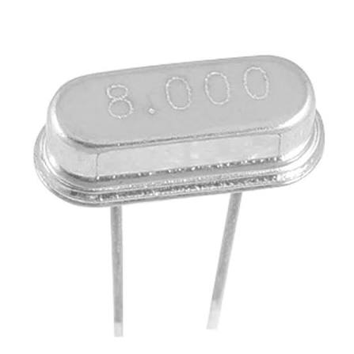
Fig. 2.5

Description:
The crystal oscillator provides a clock signal to the ATmega16A microcontroller, ensuring accurate timing and execution of instructions.
Reason for Selection:
- Provides stable and accurate frequency
- Required for precise PWM generation
- Improves system reliability
- Standard frequency for AVR microcontrollers
Working Principle:
The crystal vibrates at a fixed frequency (8 MHz), generating clock pulses for MCU operation.

2.4 Specifications of Project
Microcontroller Specifications:
- Microcontroller: ATmega16A
- Clock Frequency: 16 MHz
- Flash Memory: 16KB
- GPIO Pins: 32
- PWM Channels: Timer1

Sensor Specifications:
- Sensor Type: IR Sensor
- Output: Digital
- Detection Range: 2–10 cm
- Response Time: < 10 ms

Servo Motor Specifications:
- Type: SG90 Micro Servo
- Operating Voltage: 4.8V–6V
- Rotation Range: 0°–180°
- Control: PWM Signal
- Typical Operation: 0° (closed), 90° (open)

Power Supply Specifications:
- Input Voltage: 9–12V
- Regulated Output: 5V
- Regulator: 7805 IC

System Operation Specifications:
- Gate Opening Time: < 1 second
- Gate Closing Delay: 2–5 seconds
- Control Method: PWM-based servo control
- System Type: Automatic

2.5 PWM Generation for Servo Control
The servo motor is controlled using Pulse Width Modulation (PWM) generated by Timer1 of the ATmega16A.
f_{PWM} = \frac{f_{clk}}{N \times (1 + TOP)}
- PWM period ≈ 20 ms
- Pulse width:
  - 1 ms → 0° (Gate Closed)
  - 1.5 ms → 90° (Gate Open)
  - 2 ms → 180°

2.6 System Design Considerations
- Proper grounding to avoid noise
- Stable power supply using regulator
- Accurate timing using crystal oscillator
- Efficient use of GPIO pins
- Reliable sensor placement

2.7 Summary
This chapter presented the complete design methodology of the Smart Parking Gate System. It explained the system architecture, component selection, working principle, and specifications. The use of ATmega16A ensures efficient control and reliable system performance. The next chapter will discuss development, simulation, and testing of the system.

CHAPTER 3
DEVELOPMENT AND TESTING

3.1 Introduction
This chapter presents the complete development and testing process of the Smart Parking Gate System using the ATmega16A microcontroller. It includes simulation using Proteus software, hardware implementation, circuit verification, and system testing under different operating conditions.
The main objective of this phase is to validate the system design and ensure correct operation before final implementation.

3.2 Simulation Using Proteus
3.2.1 Objective of Simulation
The primary objectives of simulation are:
- To verify the working of ATmega16A microcontroller
- To test IR sensor input response
- To analyze PWM signal generation for servo motor
- To validate gate opening and closing operation
- To check system response under different conditions

3.2.2 Simulation Setup

The simulation was carried out using Proteus Design Suite, which supports both analog and digital simulation.
The circuit consists of:
- ATmega16A microcontroller
- IR sensor (simulated using switch or logic input)
- Servo motor (or equivalent model)
- Power supply (5V)
- Crystal oscillator ( MHz)

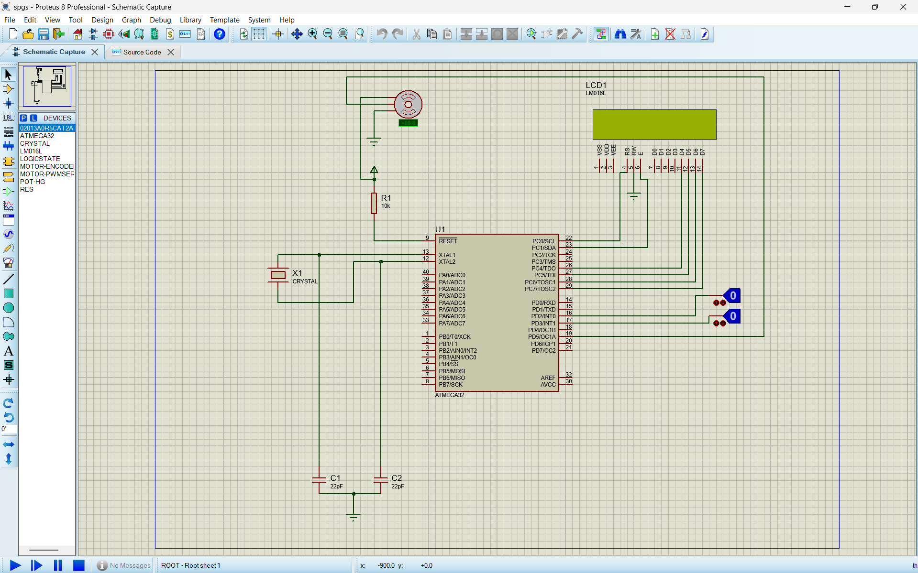
Fig. 3.1

3.2.3 Simulation Working (Using LogicState)
In this project, the IR sensor is simulated using the LOGICSTATE component in Proteus. Since Proteus does not provide a real IR sensor module with physical behavior, the LogicState is used to represent digital HIGH and LOW signals.
The LogicState acts as a manual switch to simulate vehicle detection:
- LogicState = 0 (LOW) → No vehicle detected
- LogicState = 1 (HIGH) → Vehicle detected
When the LogicState is set to HIGH, it simulates the condition where a vehicle interrupts the IR sensor beam. This signal is given as input to the ATmega16A microcontroller through the input pin (PORTD).
The microcontroller continuously monitors this input. When a HIGH signal is detected, the microcontroller executes the control logic and generates a PWM signal using Timer1. This PWM signal is sent to the servo motor connected to the output pin (PORTB).
As a result:
- The servo motor rotates to approximately 90°, opening the gate
- After a delay of 5 seconds, the microcontroller resets the PWM signal
- The servo motor returns to 0°, closing the gate
This method allows accurate testing of the system logic without requiring a physical IR sensor.

3.2.4 Advantages of Using LogicState
- Simple and easy to use in simulation
- Allows manual testing of different input conditions
- Eliminates need for complex sensor modeling
- Provides clear verification of microcontroller logic

3.2.5 Limitations of LogicState Simulation
- Does not represent real IR sensor behavior
- No distance-based detection
- No environmental effects (light, noise)
- Manual switching required

3.2.6 Conclusion of Simulation
The use of LogicState successfully verified the functionality of the Smart Parking Gate System. The microcontroller responded correctly to simulated inputs, and PWM-based servo control was validated. The system behavior matched the expected real-world operation.

3.3 PCB Artwork

3.3.1 Introduction
Printed Circuit Board (PCB) design is a crucial stage in converting the schematic into a physical and reliable hardware system. In this project, the PCB design of the Smart Parking Gate System is carried out using EasyEDA. The PCB integrates the ATmega16A microcontroller, crystal oscillator, power supply section, servo motor interface, IR input header, and LCD interface in a compact layout.

3.3.2 PCB Design Tool – EasyEDA
The PCB was designed using EasyEDA, an online Electronic Design Automation (EDA) tool.
Features used:
- Schematic to PCB conversion
- Footprint assignment
- Netlist generation
- Track routing
- Design Rule Check (DRC)
- 3D PCB visualization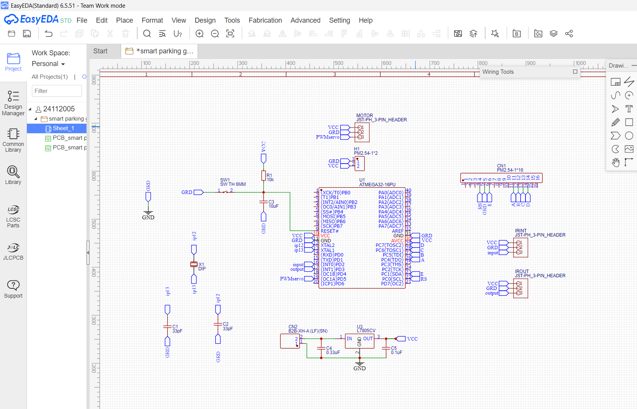
Fig. 3.2

3.3.3 PCB Layout (Top View)
The PCB layout shows the routing of connections between all components. The design is implemented as a dual-layer PCB, where:
- Red tracks represent the top layer
- Blue tracks represent the bottom layer
Observations from Layout:
- ATmega16A (DIP-40) is placed centrally
- Crystal oscillator and capacitors are placed close to MCU
- Power supply section is placed at the bottom
- Input and output headers (IR, MOTOR, IROUT) are placed at edges
- Tracks are routed with minimal overlap and proper spacing
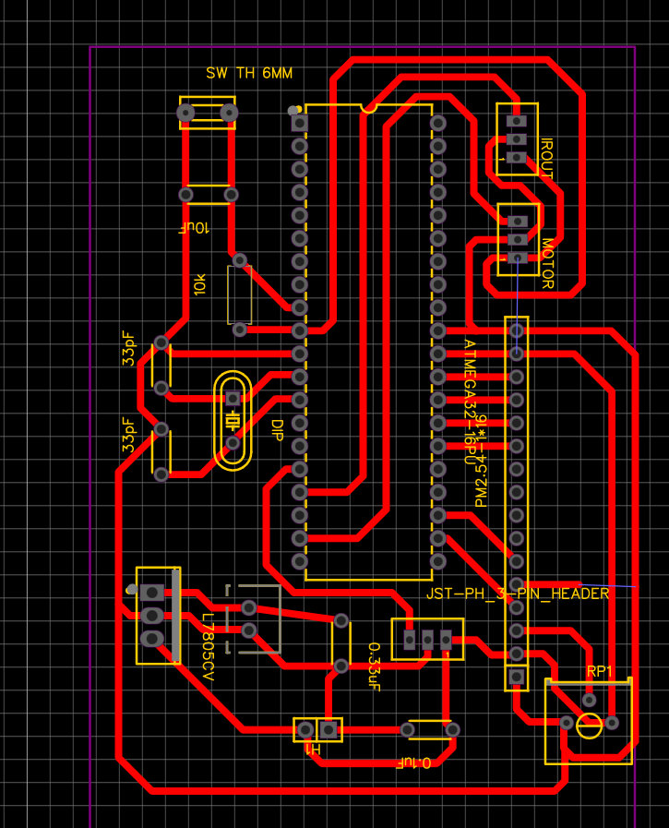
Fig. 3.3

3.3.4 3D PCB View
The 3D view provides a realistic visualization of the PCB after assembly.
Observations from 3D View:
- DIP-40 microcontroller is properly mounted
- Capacitors and crystal are correctly positioned
- Voltage regulator section is clearly visible
- Connectors for motor and IR sensor are accessible
- Component placement is compact and organized
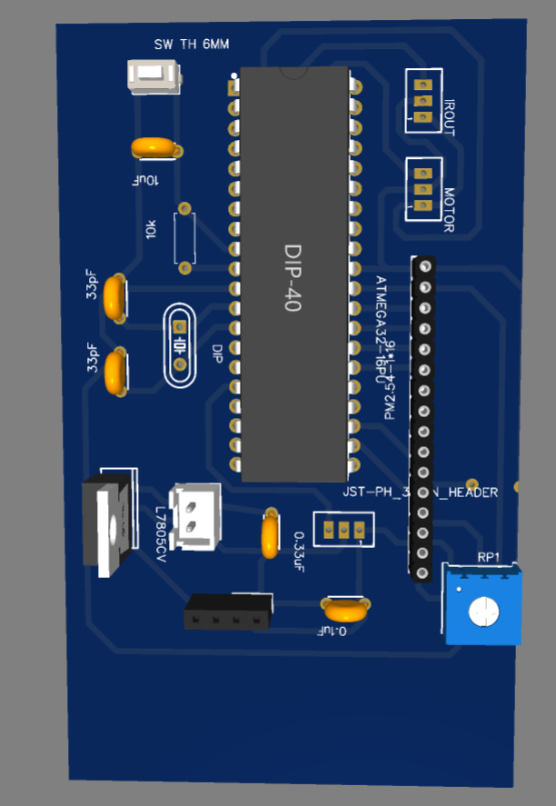
Fig. 3.4

3.3.5 Component Placement Strategy
- Microcontroller placed at center for easy routing
- Crystal placed near XTAL pins to reduce noise
- Capacitors placed near power pins for decoupling
- Headers placed near edges for external connections
- Power section isolated from signal lines

3.3.6 PCB Routing Strategy
- Power tracks are made thicker for current handling
- Signal tracks are kept short to reduce interference
- Proper separation between analog and digital lines
- Ground connections are properly maintained
- Minimal track crossing used

3.3.7 Design Considerations
- Decoupling capacitors used near VCC pins
- Stable power supply ensured using 7805 regulator
- Proper reset circuit implemented
- Avoidance of sharp bends in tracks
- Adequate spacing maintained between tracks

3.3.8 Advantages of PCB Design
- Compact and professional design
- Reduced wiring errors
- Improved signal integrity
- Easy maintenance and debugging
- Suitable for real-time embedded applications

3.3.9 Conclusion
The PCB design developed using EasyEDA successfully integrates all components required for the Smart Parking Gate System. The dual-layer routing, proper component placement, and optimized layout ensure reliable and efficient system performance. The 3D visualization confirms the practical feasibility of the design.

3.4 Layout Versus Schematic Verification Report
3.4.1 Introduction
Layout Versus Schematic (LVS) verification is an important step in PCB design that ensures the physical PCB layout accurately represents the intended schematic design. It verifies that all electrical connections, components, and signal paths in the PCB layout match the original schematic.

3.4.2 Objective of LVS Verification
The objectives of LVS verification in this project are:
- To ensure all components are correctly connected
- To verify that no connections are missing or incorrect
- To detect short circuits and open circuits
- To confirm correct mapping between schematic and PCB layout
- To validate the overall integrity of the design

3.4.3 Verification Process
The following steps were carried out for verification:
- Netlist Generation:
The netlist was generated from the schematic in EasyEDA.
- PCB Layout Comparison:
The generated netlist was compared with the PCB layout connections.
- Design Rule Check (DRC):
The PCB design was checked for spacing, track width, and clearance violations.
- Manual Inspection:
Critical connections such as:
  - Microcontroller pins
  - Power supply lines (VCC, GND)
  - Crystal oscillator connections
  - Servo motor output
  - IR sensor input
were verified manually.

3.4.4 Verification Results
The LVS verification confirmed the following:
- All components are correctly placed and connected
- No missing connections were found
- No short circuits or open circuits detected
- Power and ground connections are properly routed
- Signal connections match the schematic design
- Crystal oscillator and capacitors are correctly connected

3.4.5 DRC Report Summary
- No design rule violations detected
- Track width and spacing are within acceptable limits
- All pads and vias are correctly connected

3.4.6 Observations
- The PCB layout accurately reflects the schematic
- Proper routing techniques are used
- Component placement is optimized for performance
- Noise-sensitive components are placed appropriately

3.4.7 Conclusion
The Layout Versus Schematic verification confirms that the PCB design is correct and consistent with the schematic. The design is free from errors such as open circuits, short circuits, and incorrect connections. Therefore, the PCB is suitable for fabrication and implementation of the Smart Parking Gate System.

CHAPTER 4
EMI & EMC STANDARDS IMPLEMENTED IN THE PROJECT

4.1 Introduction
This chapter describes the Electromagnetic Interference (EMI) and Electromagnetic Compatibility (EMC) considerations implemented in the Smart Parking Gate System. It focuses on techniques used to reduce noise, improve signal integrity, and ensure reliable operation of the system.

4.2 EMI & EMC Standards Applied in the Project
In embedded systems, EMI refers to unwanted electromagnetic noise that can affect circuit performance, while EMC ensures that the system operates correctly without causing or being affected by interference.
The following EMI/EMC practices and standards were applied in this project:

1. Proper Grounding Technique
- A common ground (GND) is maintained throughout the circuit
- All components share a single reference point
- Ground loops are avoided to reduce noise

2. Decoupling Capacitors
- Capacitors (0.1µF and 10µF) are placed near VCC pins of ATmega16A
- These capacitors filter high-frequency noise
- They stabilize voltage supply to the microcontroller

3. Power Supply Filtering
- 7805 voltage regulator is used to provide stable 5V output
- Input and output capacitors are used to reduce ripple
- Ensures smooth operation of the system

4. Short Signal Paths
- PCB tracks are kept short to reduce signal distortion
- Critical signals like PWM are routed carefully
- Minimizes electromagnetic radiation

5. Separation of Power and Signal Lines
- Power lines (VCC, GND) are separated from signal lines
- Prevents noise coupling into control signals
- Improves system reliability

6. Crystal Oscillator Placement
- Crystal oscillator is placed close to ATmega16A
- Reduces noise in clock signal
- Ensures accurate timing and PWM generation

7. Avoidance of Sharp Track Bends
- Smooth routing is used instead of sharp angles
- Reduces signal reflection and interference

8. Stable PWM Signal Routing
- PWM output line is kept away from noisy power lines
- Ensures stable servo motor operation

4.3 Summary
The implementation of EMI and EMC design practices improves the stability and reliability of the Smart Parking Gate System. Proper grounding, filtering, and layout techniques help in minimizing noise and ensuring smooth system performance.

CHAPTER 5
RESULTS

5.1 Introduction
This chapter presents the results obtained from the simulation and testing of the Smart Parking Gate System using the ATmega16A microcontroller. The system performance is evaluated based on its response to sensor inputs, accuracy of operation, and overall reliability.

5.2 Simulation Results
The system was simulated using Proteus Design Suite. The IR sensor behavior was represented using the LogicState component to simulate vehicle detection.
The following observations were made during simulation:
- When LogicState = LOW (0), no vehicle is detected, and the gate remains closed
- When LogicState = HIGH (1), the system detects a vehicle and opens the gate
- The servo motor rotates to approximately 90° when the gate opens
- After a delay of 5 seconds, the gate closes automatically
- PWM signal generated by Timer1 controls servo movement accurately
The simulation confirms that the logic implemented in the microcontroller works correctly.

5.3 Hardware Results
The system was implemented and tested using actual hardware components. The performance was observed under different conditions.
- The IR sensor successfully detects the presence of a vehicle
- The ATmega16A processes the input signal without delay
- The servo motor responds quickly and rotates smoothly
- The gate opens and closes automatically without manual intervention
- The system operates continuously without errors

5.4 Observation Table
Test Condition | Input (IR Sensor / LogicState) | Output (Servo Position) | Result
No vehicle present | LOW (0) | 0° (Closed) | Correct
Vehicle detected | HIGH (1) | 90° (Open) | Correct
After delay | LOW (0) | 0° (Closed) | Correct
Continuous operation | Repeated signals | Open/Close cycles | Stable

5.5 Performance Analysis
- Response Time: Less than 1 second
- Accuracy: High for short-range detection
- Reliability: Stable operation under repeated testing
- Power Consumption: Low
- System Efficiency: Good for small-scale applications

5.6 Result Discussion
The Smart Parking Gate System successfully achieves automatic gate control using sensor input and microcontroller processing. The use of PWM ensures precise control of the servo motor. The system performs efficiently with minimal delay and high reliability.
The results demonstrate that the design is suitable for real-world implementation in small parking areas.

5.7 Conclusion
The results obtained from both simulation and hardware testing confirm that the Smart Parking Gate System functions as intended. The system is reliable, efficient, and capable of automating parking gate operations effectively.

CHAPTER 6
CONCLUSIONS AND FUTURE SCOPE

6.1 Conclusion
The Smart Parking Gate System using the ATmega16A microcontroller has been successfully designed, simulated, and implemented. The system effectively automates the process of vehicle entry and exit by detecting the presence of a vehicle using an IR sensor and controlling the gate using a servo motor.
The use of the ATmega16A microcontroller enables efficient processing of sensor inputs and precise control of the servo motor through PWM signals. The system demonstrates reliable performance with quick response time and stable operation under different test conditions.
The project achieves its primary objectives of reducing manual effort, improving parking efficiency, and providing a low-cost automation solution. The integration of hardware and software showcases the practical application of embedded systems in real-world scenarios.
Overall, the Smart Parking Gate System is simple, cost-effective, and suitable for small to medium-scale parking applications such as residential complexes, educational institutions, and office premises.

6.2 Future Scope
Although the system performs efficiently, it can be further enhanced by incorporating advanced features and technologies:
- RFID-Based Access Control:
Integration of RFID technology can enable authorized vehicle entry and improve security.
- IoT Integration:
Connecting the system to the internet allows remote monitoring and control using mobile applications.
- Parking Slot Display System:
An LCD or LED display can be used to show the availability of parking spaces.
- Automatic Number Plate Recognition (ANPR):
Camera-based systems can be added for vehicle identification and tracking.
- Ultrasonic Sensors:
Can be used for more accurate distance-based vehicle detection.
- Solar Power Integration:
The system can be made energy-efficient by using renewable energy sources.
- Multi-Gate Control System:
Expansion to manage multiple entry and exit points in large parking areas.

CHAPTER 7
BILL OF MATERIAL

7.1 Introduction
This chapter presents the list of components used in the Smart Parking Gate System along with their specifications, quantities, and approximate cost. The selection of components is based on availability, cost-effectiveness, and compatibility with the ATmega16A microcontroller.

7.2 Bill of Materials Table

Bill of Materials Table
Sr. No. | Component Name | Specification | Quantity | Approx. Cost (₹)
1 | ATmega16A Microcontroller | 8-bit AVR, DIP-40 | 1 | 150
2 | IR Sensor Module | Digital Output, 5V | 2 | 50
3 | Servo Motor (SG90) | 0°–180°, 5V | 1 | 150
4 | 7805 Voltage Regulator | 5V Output | 1 | 20
5 | Crystal Oscillator | 16 MHz | 1 | 20
6 | Capacitors | 33pF, 0.1µF, 10µF | 3–5 | 30
7 | Resistors | 10kΩ, 1kΩ | 2–3 | 10
8 | LCD Display (16x2) (if used) | 5V, HD44780 | 1 | 120
9 | Jumper Wires | Male-Male | 1 set | 50
10 | PCB / Breadboard | General purpose | 1 | 100

Total Cost Estimate
Total Approximate Cost: ₹700
REFERENCES

Books:
[1] Muhammad Ali Mazidi, Sarmad Naimi and Sepehr Naimi, “The AVR Microcontroller and Embedded Systems”, Pearson Education, 2011.

Transactions / Journals:
[2] S. Patil and R. Kulkarni, “Design and Implementation of Smart Parking System,” International Journal of Engineering Research and Technology (IJERT), vol. 9, no. 5, pp. 234–238, 2020.

International / National Conference Proceedings:
[3] M. Yusnita, Y. Norazwinawati and B. Fariza, “Intelligent Parking Space Detection System Based on Image Processing,” International Conference on Innovation Management and Technology Research, Malaysia, 2012.

Standards:
[4] IPC-2221B, “Generic Standard on Printed Board Design”, IPC — Association Connecting Electronics Industries, 2012.
[5] IEC 61000-4-2, “Electromagnetic Compatibility – Electrostatic Discharge Immunity Test”, International Electrotechnical Commission, 2008.

Datasheets / Technical Reports:
[6] Microchip Technology Inc., “ATmega16A Complete Datasheet”, Document No. 8154D–AVR–09/2013.
[7] TowerPro, “SG90 Servo Motor Datasheet”, Rev. 1.0.
[8] IR Sensor Module Datasheet, Generic Infrared Obstacle Detection Module.
[9] Texas Instruments, “LM7805 Voltage Regulator Datasheet”, Document No. SNVS774.
Websites:
[11] EasyEDA Documentation, Internet: https://docs.easyeda.com
[12] Microchip Technology Inc., “ATmega16A Product Page”, Internet: https://www.microchip.com
[13] Electronics Tutorials, Internet: https://www.electronics-tutorials.ws
[14] Arduino Official Website, Internet: https://www.arduino.cc

